Task 1
Create a supply table with the same structure as the book table.
Field | Type, Description
supply_id | INT PRIMARY KEY AUTO_INCREMENT
title | VARCHAR(50)
author | VARCHAR(30)
price | DECIMAL(8, 2)
amount | INT

Inserting Records into a Table
Adding a single record to a table is done using the INSERT query, which was covered in detail in the first lesson. Queries must be separated by semicolons.
It is also possible to insert multiple records at once using an SQL query of the following format:
INSERT INTO table_name(column_1, column_2, ..., column_N)
VALUES
(value_1_1, value_1_2, ..., value_1_N),
(value_2_1, value_2_2, ..., value_2_N),
...
(value_M_1, value_M_2, ..., value_M_N);

For example, to add two new records to the book table, use the following query:
INSERT INTO book (title, author, price, amount)
VALUES ('Война и мир','Толстой Л.Н.', 1070.20, 2), ('Анна Каренина', 'Толстой Л.Н.', 599.90, 3);

Task 2
Insert four records into the supply table to get the following table:

supply_id | title | author | price | amount
1 | Лирика | Пастернак Б.Л. | 518.99 | 2
2 | Черный человек | Есенин С.А. | 570.20 | 6
3 | Белая гвардия | Булгаков М.А. | 540.50 | 7
4 | Идиот | Достоевский Ф.М. | 360.80 | 3

Note: To view the resulting table after the insert query (queries), include a SELECT query to retrieve all data from the supply table.

Result:
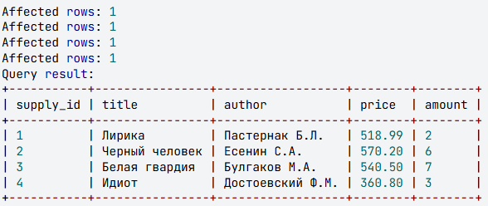
Inserting Records from Another Table
Using an INSERT query, you can add not only specific values (using the VALUES list) but also records from another table selected via a SELECT query. In this case, instead of the VALUES clause, a SELECT query is written. You can use WHERE, GROUP BY, and ORDER BY in this SELECT query.
The rules for matching between table fields and inserted values from the query are as follows:
- The number of fields in the table and the number of fields in the query must match;
- There must be a direct correspondence between the position of each element in both lists. Therefore, the first column in the query must correspond to the first column in the table's column list, the second to the second column, and so on;
- When inserting values, SQL attempts to convert them to the field's data type. For example, inserting the string '1' into a numeric field will convert it to the integer 1. However, attempting to insert the string 'ab' into a numeric field will cause an error, and the record will not be inserted;
- To avoid errors, it is advisable to follow the rule: "The data types of the elements in the value list must be compatible with the data types of the corresponding table columns" (an integer can be inserted into a DECIMAL field, but the reverse operation will round the real number, which may affect data accuracy);
- It is not recommended to add new values to fields described as PRIMARY KEY AUTO_INCREMENT;
- It is recommended to fill in all fields of the record. If a field is omitted, its value depends on the default settings. If no default is set, NULL is inserted into the field.

Example
Add all books from the supply table to the book table.
INSERT INTO book (title, author, price, amount) SELECT title, author, price, amount FROM supply;
SELECT * FROM book;
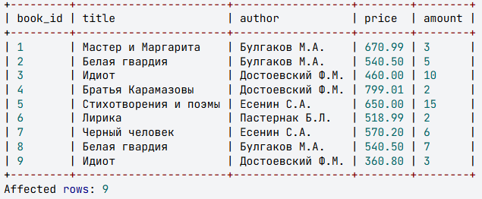

This query has inserted all books from the supply table into the book table, including those that already exist in book ("Белая гвардия" and "Идиот"). As a result, the same book, for example "Белая гвардия", now has two different IDs (2 and 8). This is an undesirable situation for the relational model.
This problem can be resolved using subqueries, which will be covered in the next step.

Task 3
Add to the book table from the supply table all books except those written by Bulgakov M.A. and Dostoevsky F.M.
Result:
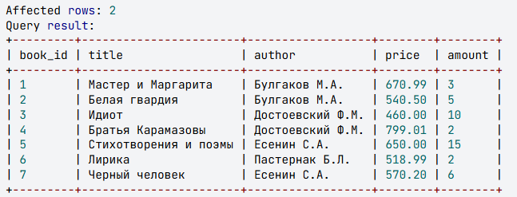
Inserting Records with Subqueries
Subqueries can be used in INSERT statements.
Example
Insert into the book table from the supply table only those books whose titles are not present in the book table.

INSERT INTO book (title, author, price, amount)
SELECT title, author, price, amount
FROM supply
WHERE title NOT IN (
SELECT title
FROM book
);

SELECT * FROM book;

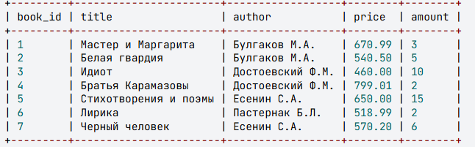
Task 4
Insert into the book table from the supply table only those books whose authors are not present in book.

Result:
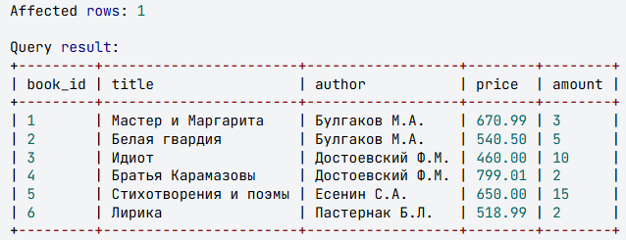
Update Queries
Data updating refers to modifying values in existing records of a table. This can involve changing field values in a group of rows (even all rows in the table) or editing the value of a specific field in an individual row.
Updating records in a table is implemented using the UPDATE query. The simplest update query looks like this:
UPDATE book
SET price = 0.7 * price;

SELECT * FROM book;Where:
- table - the name of the table where changes will be made;
- field - the table field that will be modified;
- expression - the expression whose value will be inserted into the field.
Example
Reduce the price of books in the book table by 30%.

Update queries can modify not all records in a table (as in the previous example), but only a specific subset of them. This is achieved by including the WHERE keyword in the query, followed by a condition that filters which rows should be updated.
Example
Reduce the price by 30% for those books in the book table where the quantity is less than 5.
UPDATE book
SET price = 0.7 * price
WHERE amount < 5;

SELECT * FROM book;

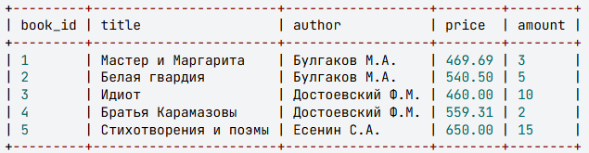

Task 5
Reduce the price by 10% for those books in the book table where the quantity belongs to the interval from 5 to 10, including the boundaries.

Result:
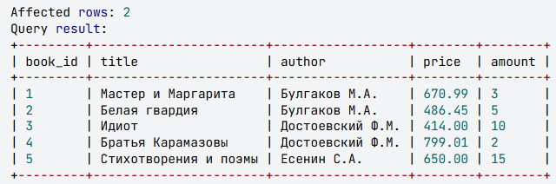

Queries for Updating Multiple Columns
The UPDATE query can update values in multiple columns simultaneously. In this case, the basic query would look like this: In the warehouse, in addition to storing and receiving books, wholesale sales are conducted. To implement this functionality, we'll add an additional column buy to the book table:
UPDATE table SET field1 = expression1, field2 = expression2

book_id | title | author | price | amount | buy
INT PRIMARY KEY AUTO_INCREMENT | VARCHAR(50) | VARCHAR(30) | DECIMAL(8,2) | INT | INT
1 | Мастер и Маргарита | Булгаков М.А. | 670.99 | 3 | 0
2 | Белая гвардия | Булгаков М.А. | 540.50 | 5 | 3
3 | Идиот | Достоевский Ф.М. | 460.00 | 10 | 8
4 | Братья Карамазовы | Достоевский Ф.М. | 799.01 | 2 | 0
5 | Стихотворения и поэмы | Есенин С.А. | 650.00 | 15

Example:
In the context of book wholesale operations, we might need to update both price and quantity for certain books:
UPDATE book
SET amount = amount - buy, buy = 0;

SELECT * FROM book;

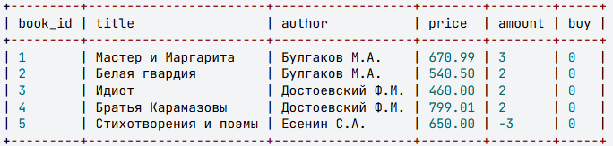

Task 6
In the book table, it's necessary to adjust the value for the buyer in the buy column so that it does not exceed the number of book copies specified in the amount column. And reduce the price of those books that the buyer did not order by 10%.
Result:

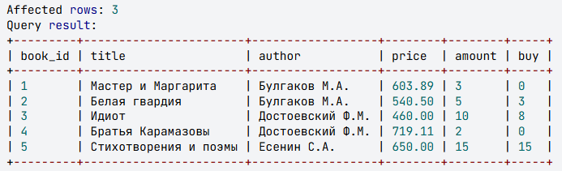

Note:
The query to update the quantity of books should adjust the values in the buy column of the book table as follows:
- If the customer ordered more books than are available in stock, replace the buy value with the available stock quantity amount;
- If the customer wants to buy a quantity of books less than or equal to the quantity in stock, the buy value should not be changed.
To implement this query, you can use the IF() function. The syntax for the SET clause when using the IF() function is as follows:
SET column = IF(condition, expression_1, expression_2)
This operator works as follows:
- First, the condition is evaluated;
- If the condition is TRUE, then expression_1 is evaluated; otherwise (if the condition is FALSE), expression_2 is evaluated;
- The column receives the result of the function (either the value of expression_1 or the value of expression_2, depending on the condition).
For example, to increase by 10% only the prices of Bulgakov's books, the following query is used:
sql
UPDATE book
SET price = IF(author = "Булгаков М.А.", price * 1.1, price);

Updates Involving Multiple Tables
Update queries can utilize multiple tables, but in such cases:
- For columns with identical names, it's necessary to specify the table they belong to, for example, book.price refers to the price column from the book table, while supply.price refers to the price column from the supply table;
- All tables used in the query must be listed after the UPDATE keyword;
- The query must include a WHERE clause that specifies the condition under which data should be updated.
Example
If the supply table contains the same books as the book table, it doesn't make sense to add these books again to the book table. Instead, it's necessary to increase their quantity by the value from the amount column in the supply table.

UPDATE book, supply
SET book.amount = book.amount + supply.amount
WHERE book.title = supply.title AND book.author = supply.author;

SELECT * FROM book;

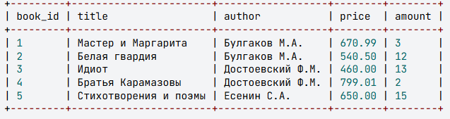

In this query, the quantity of two books has been increased: "The White Guard," which has the same price in the supply table, and "The Idiot," but the price of this book differs between the book and supply tables. For this book, the price needs to be recalculated.
Task 7
For those books in the book table that are also present in the supply table, not only increase their quantity in the book table (by adding the value from the amount column of the supply table), but also recalculate their price (for each book, find the sum of prices from the book and supply tables and divide by 2).
Result:
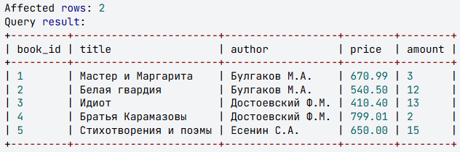
Note: Recalculation for books with the same title and price will not affect the result, so the query does not necessarily need to consider two separate cases: when the price is the same for identical books and when it differs.

Delete Queries

DELETE FROM supply;

SELECT * FROM supply;

Affected rows: 4
Affected rows: 0

All records have been deleted from the table. The SELECT query returned 0 records.
The DELETE query allows you to remove not all records from a table, but only those that meet the condition specified after the WHERE keyword:
DELETE FROM таблица
WHERE условие;

Example
Delete from the supply table all books whose titles are present in the book table.
DELETE FROM supply
WHERE title IN (
SELECT title
FROM book
);

SELECT * FROM supply;

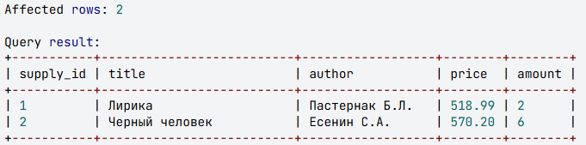

Task 8
Delete from the supply table the books by those authors whose total number of book copies in the book table exceeds 10.

Result:

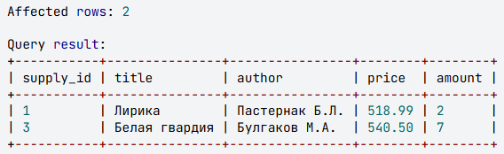
Table Creation Queries
A new table can be created based on data from another table. This is done using a SELECT query, where the result set becomes the new database table. The column names from the query become the column names of the new table. The query to create a new table has the following format:

CREATE TABLE table_name AS
SELECT ...
Example
Create a table called 'ordering' that includes authors and titles of those books where the number of copies in the 'book' table is less than 4. For all these books, specify the same quantity of 5 copies.
CREATE TABLE ordering AS
SELECT author, title, 5 AS amount
FROM book
WHERE amount < 4;

SELECT * FROM ordering;

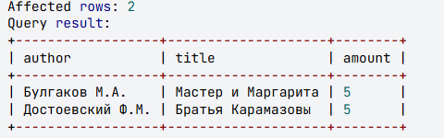
When creating a table, subqueries can be used both after SELECT and after WHERE.
Example
Create an 'ordering' table that includes authors and titles of books whose number of copies in the 'book' table is less than 4. For all books, specify the same value - the average number of book copies in the 'book' table.

CREATE TABLE ordering AS
SELECT author, title, (
SELECT ROUND(AVG(amount))
FROM book
) AS amount
FROM book
WHERE amount < 4;

SELECT * FROM ordering;

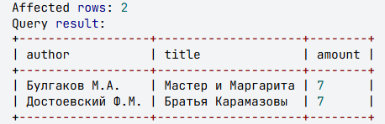

Task 9

Create an ordering table that includes authors and titles of books whose number of copies in the book table is less than the average number of book copies in the book table. Include an amount column in the table where all books are assigned the same value - the average number of book copies in the book table.
Result:

